LEARNING INTENTIONS:
- I can use common French words and phrases.
- I can create an engaging video using the digital medium.
INSTRUCTIONS:
- You will become a gourmet French chef byworking with a partner (or independently if you have spoken to Mr. Hong) to create an engaging and fun instructional video.
- Find a simple recipe to use. Some examples include Mac and Cheese, hard boiled eggs, a sandwich, etc. However, bonus points will be given for French cuisine.
- You have already seen many examples in class of what it could look like, how to engage your audience, and how to create it. You are free to use any video software you like. Some examples include movie maker, imovie, various apps, photos, etc.
- Have fun making it and work collaboratively with your group members!

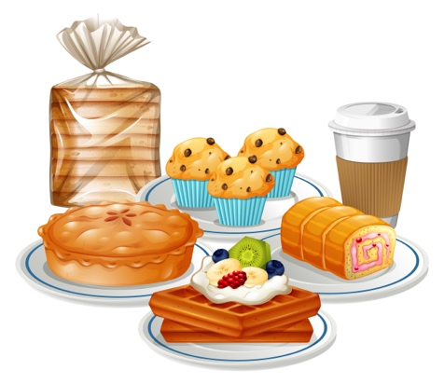
CRITERIA:
- INTRODUCTION
  - Introduce yourself and/or your group members
  - Title
- FRENCH VOCABULARY/PHRASES/TRANSLATION
  - Keep it simple.
  - Do not translate full recipe instructions you find online. The words will be too complicated. You may translate simple sentences/phrases.
  - You must understand all the words/phrases you use
  - You may use digital translation websites to help MONITOR YOUR COMPRHENSION and to help you with your pronunciation. For example: Google Translate
- SCRIPTS
  - A copy of your English and French scripts must be submitted with your video.
- PRONUNCIATION
  - Correct pronunciation must be followed. You must use various online tools like Google translate to hear the proper accents, sounds, pronunciation of the words.
- VIDEO
  - Creative use of digital editing tools
  - Engaging text, translations, sub-titles, images, video transitions, etc.
- TIME LIMIT
  - 5 minute maximum
EVALUATION:
BEGINNING | DEVELOPING | APPLYING | EXTENDING

