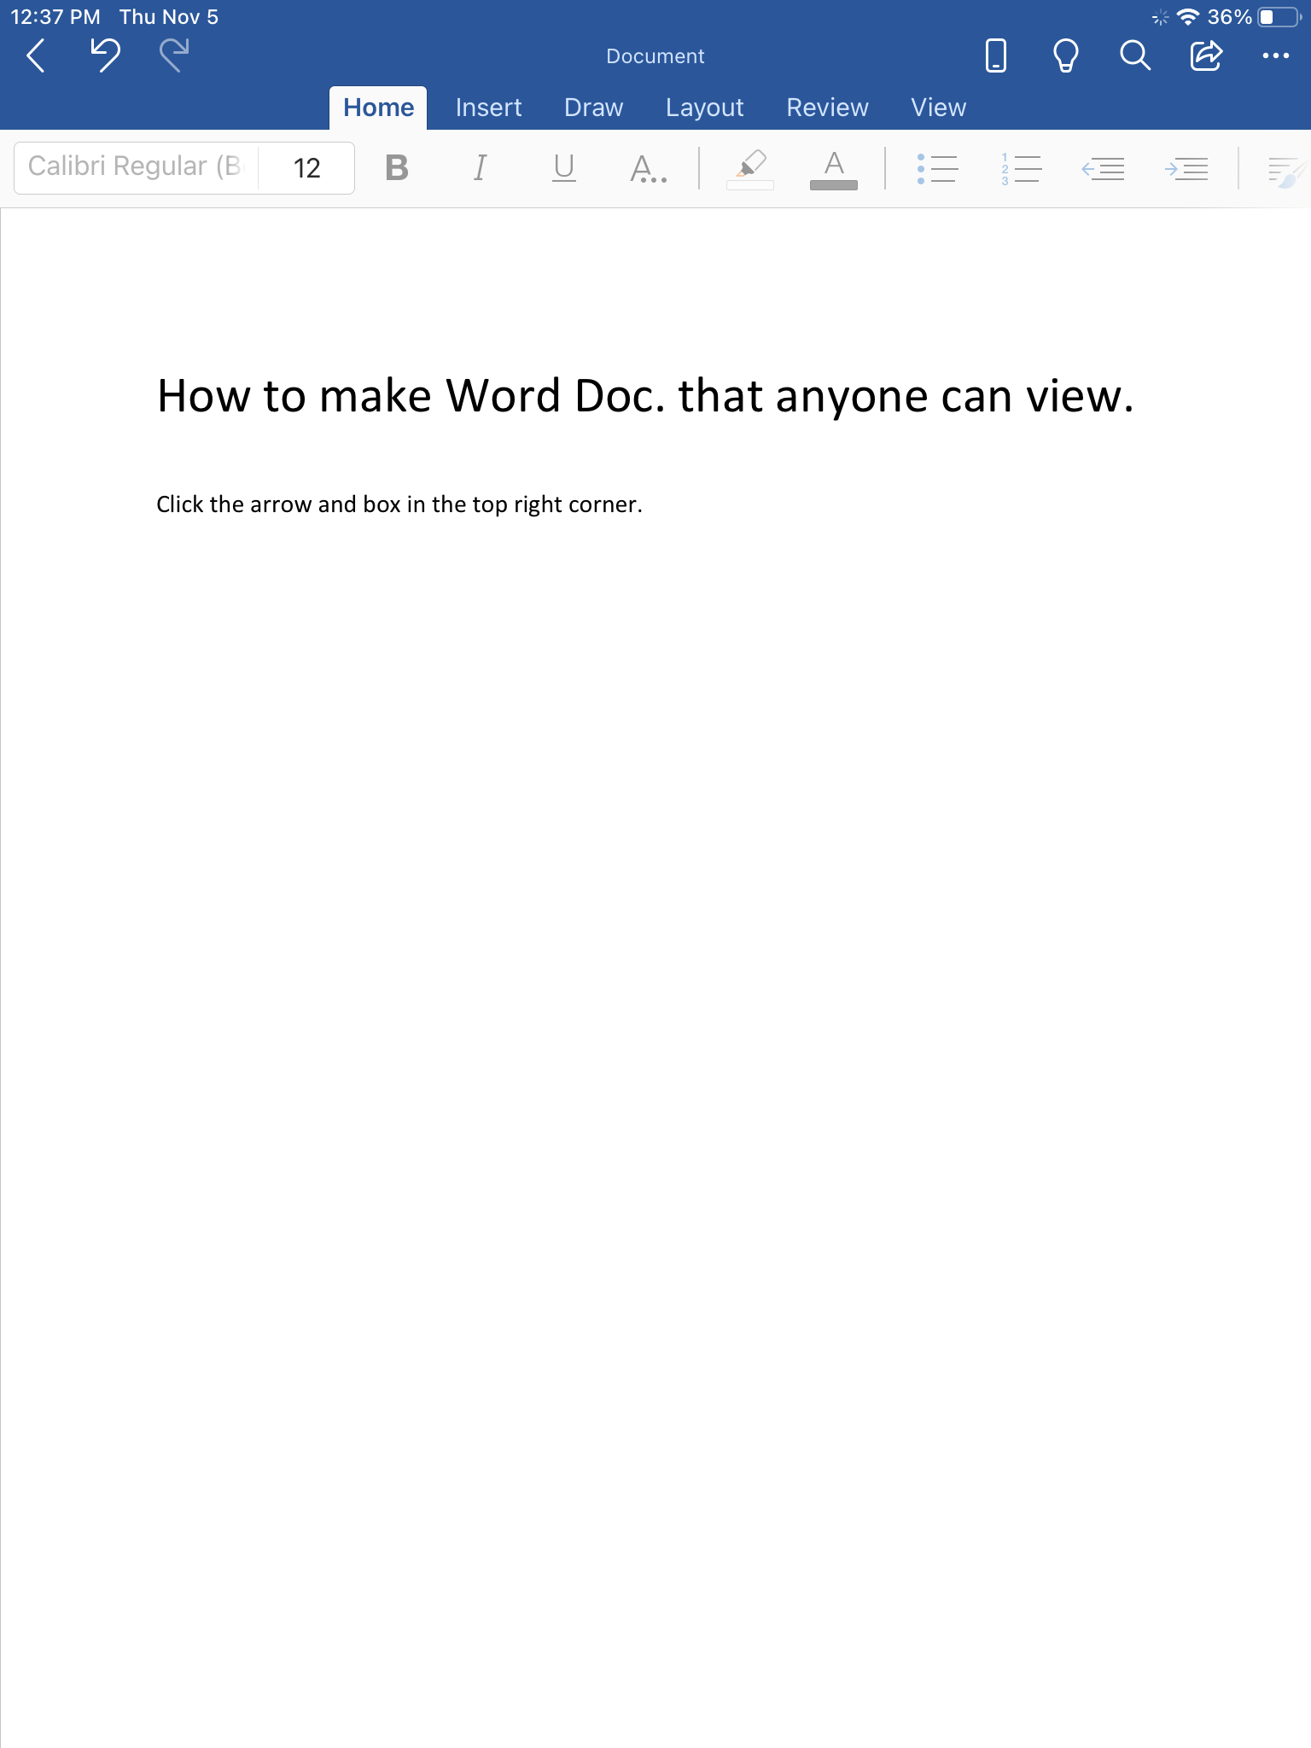
Make sure you have saved your scary short story save as Scary Short Story (add your name). Click arrow and box.
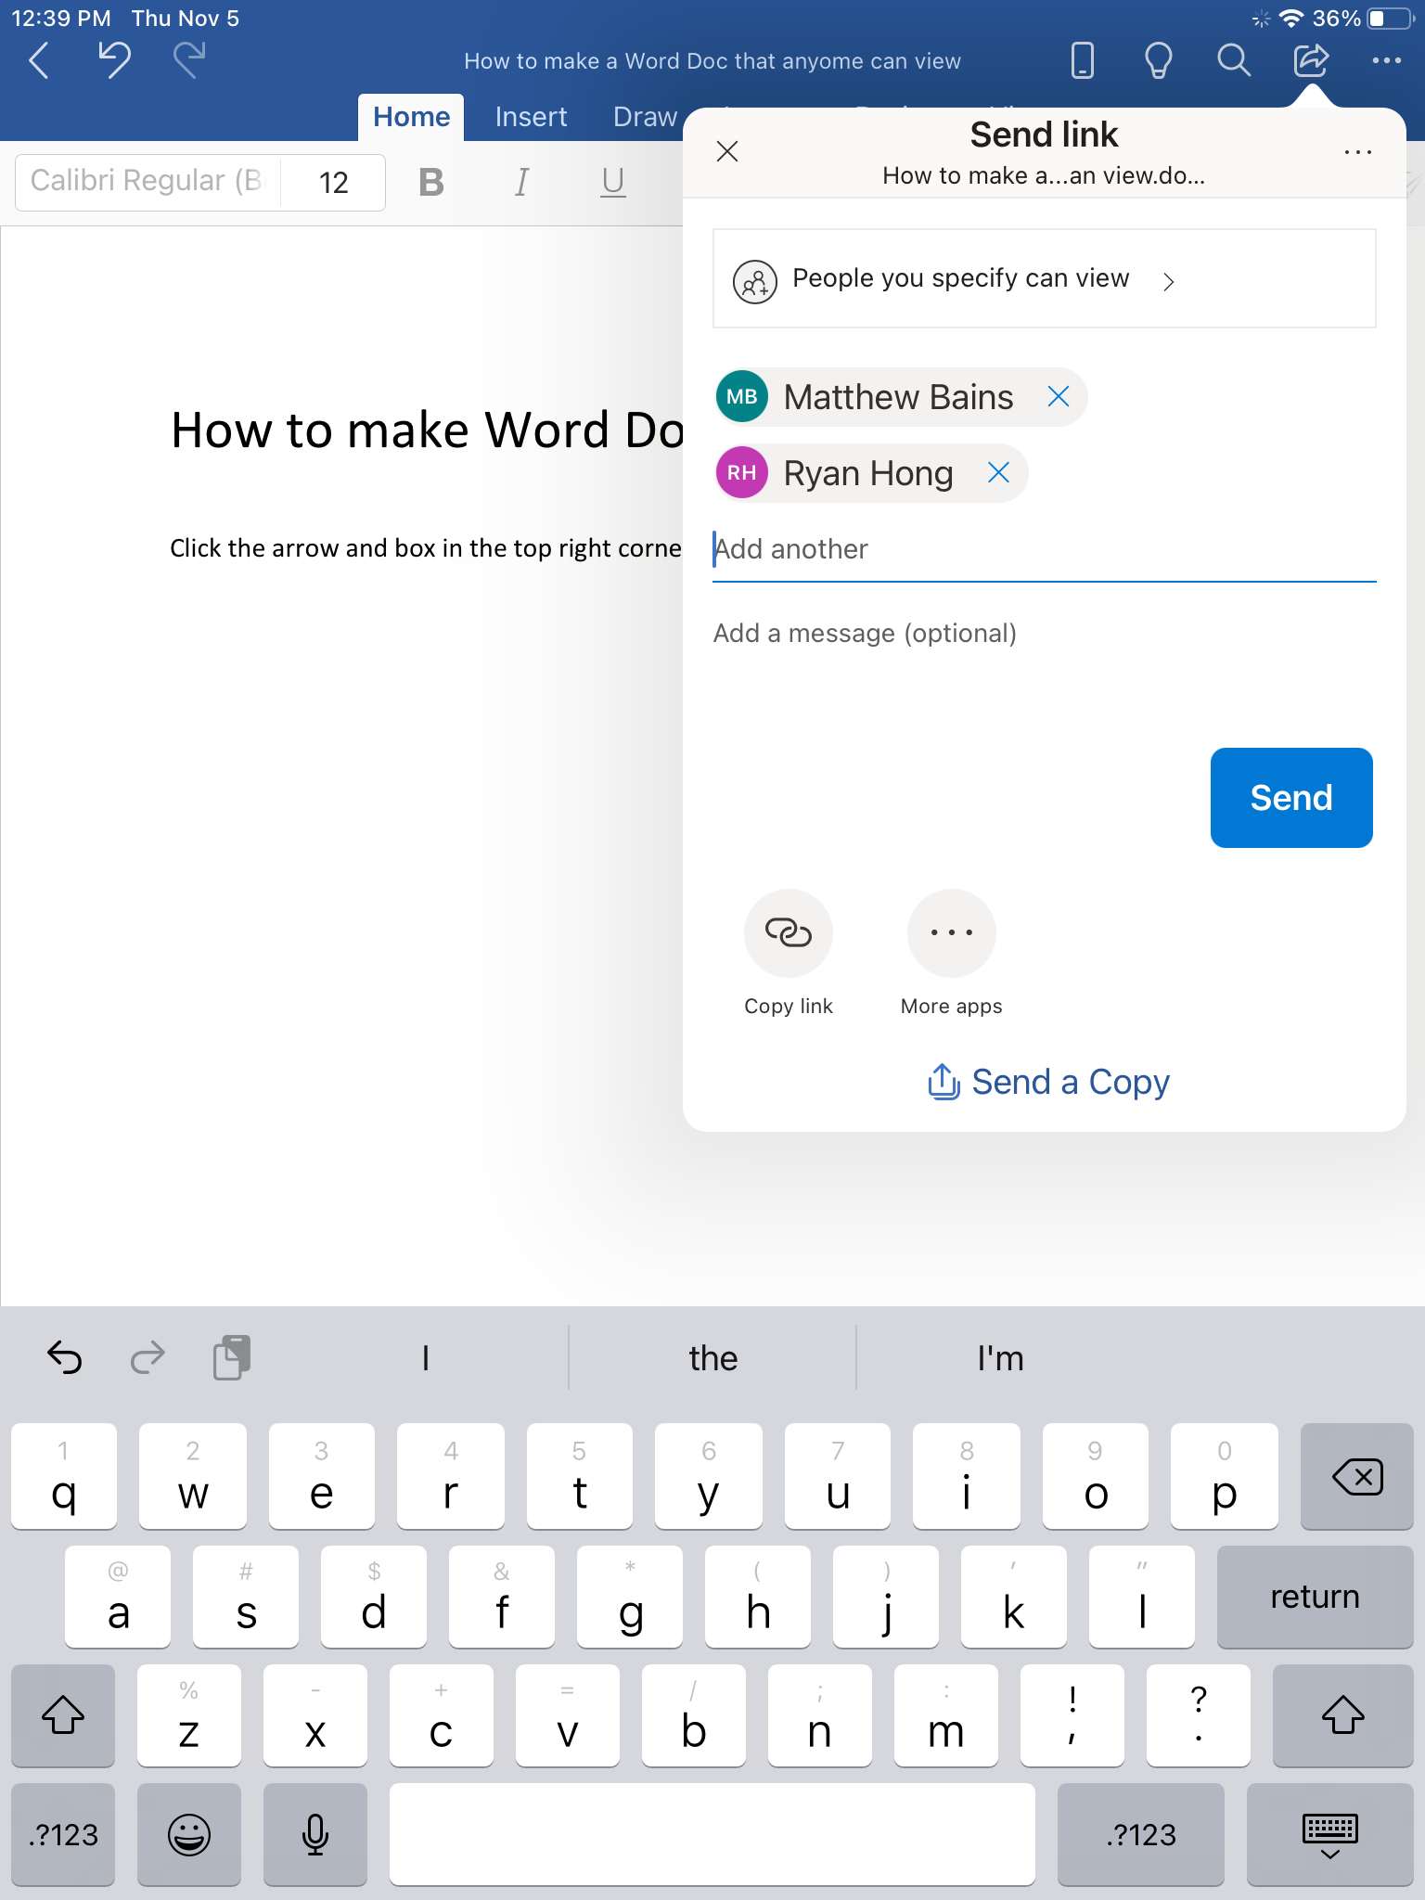
Share with Matthew Bains and Mr. Hong.
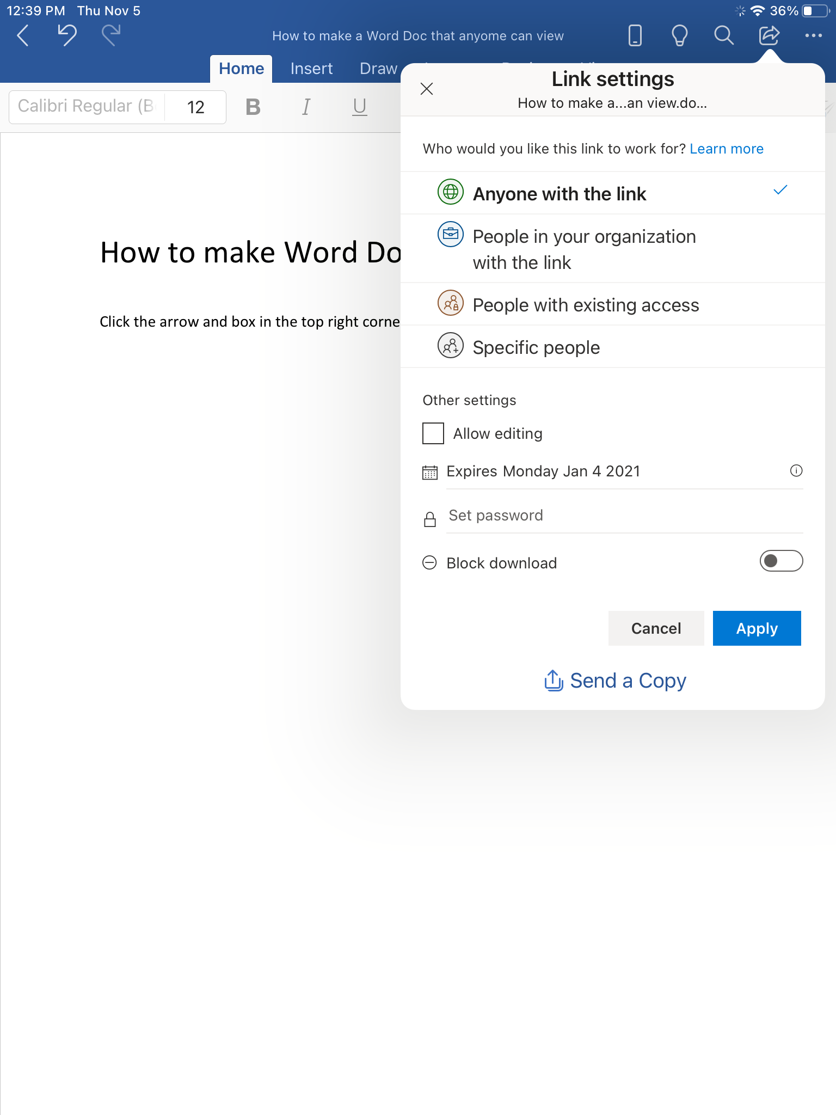
Next, click “People you specify can view” and then select “Anyone with the link”.
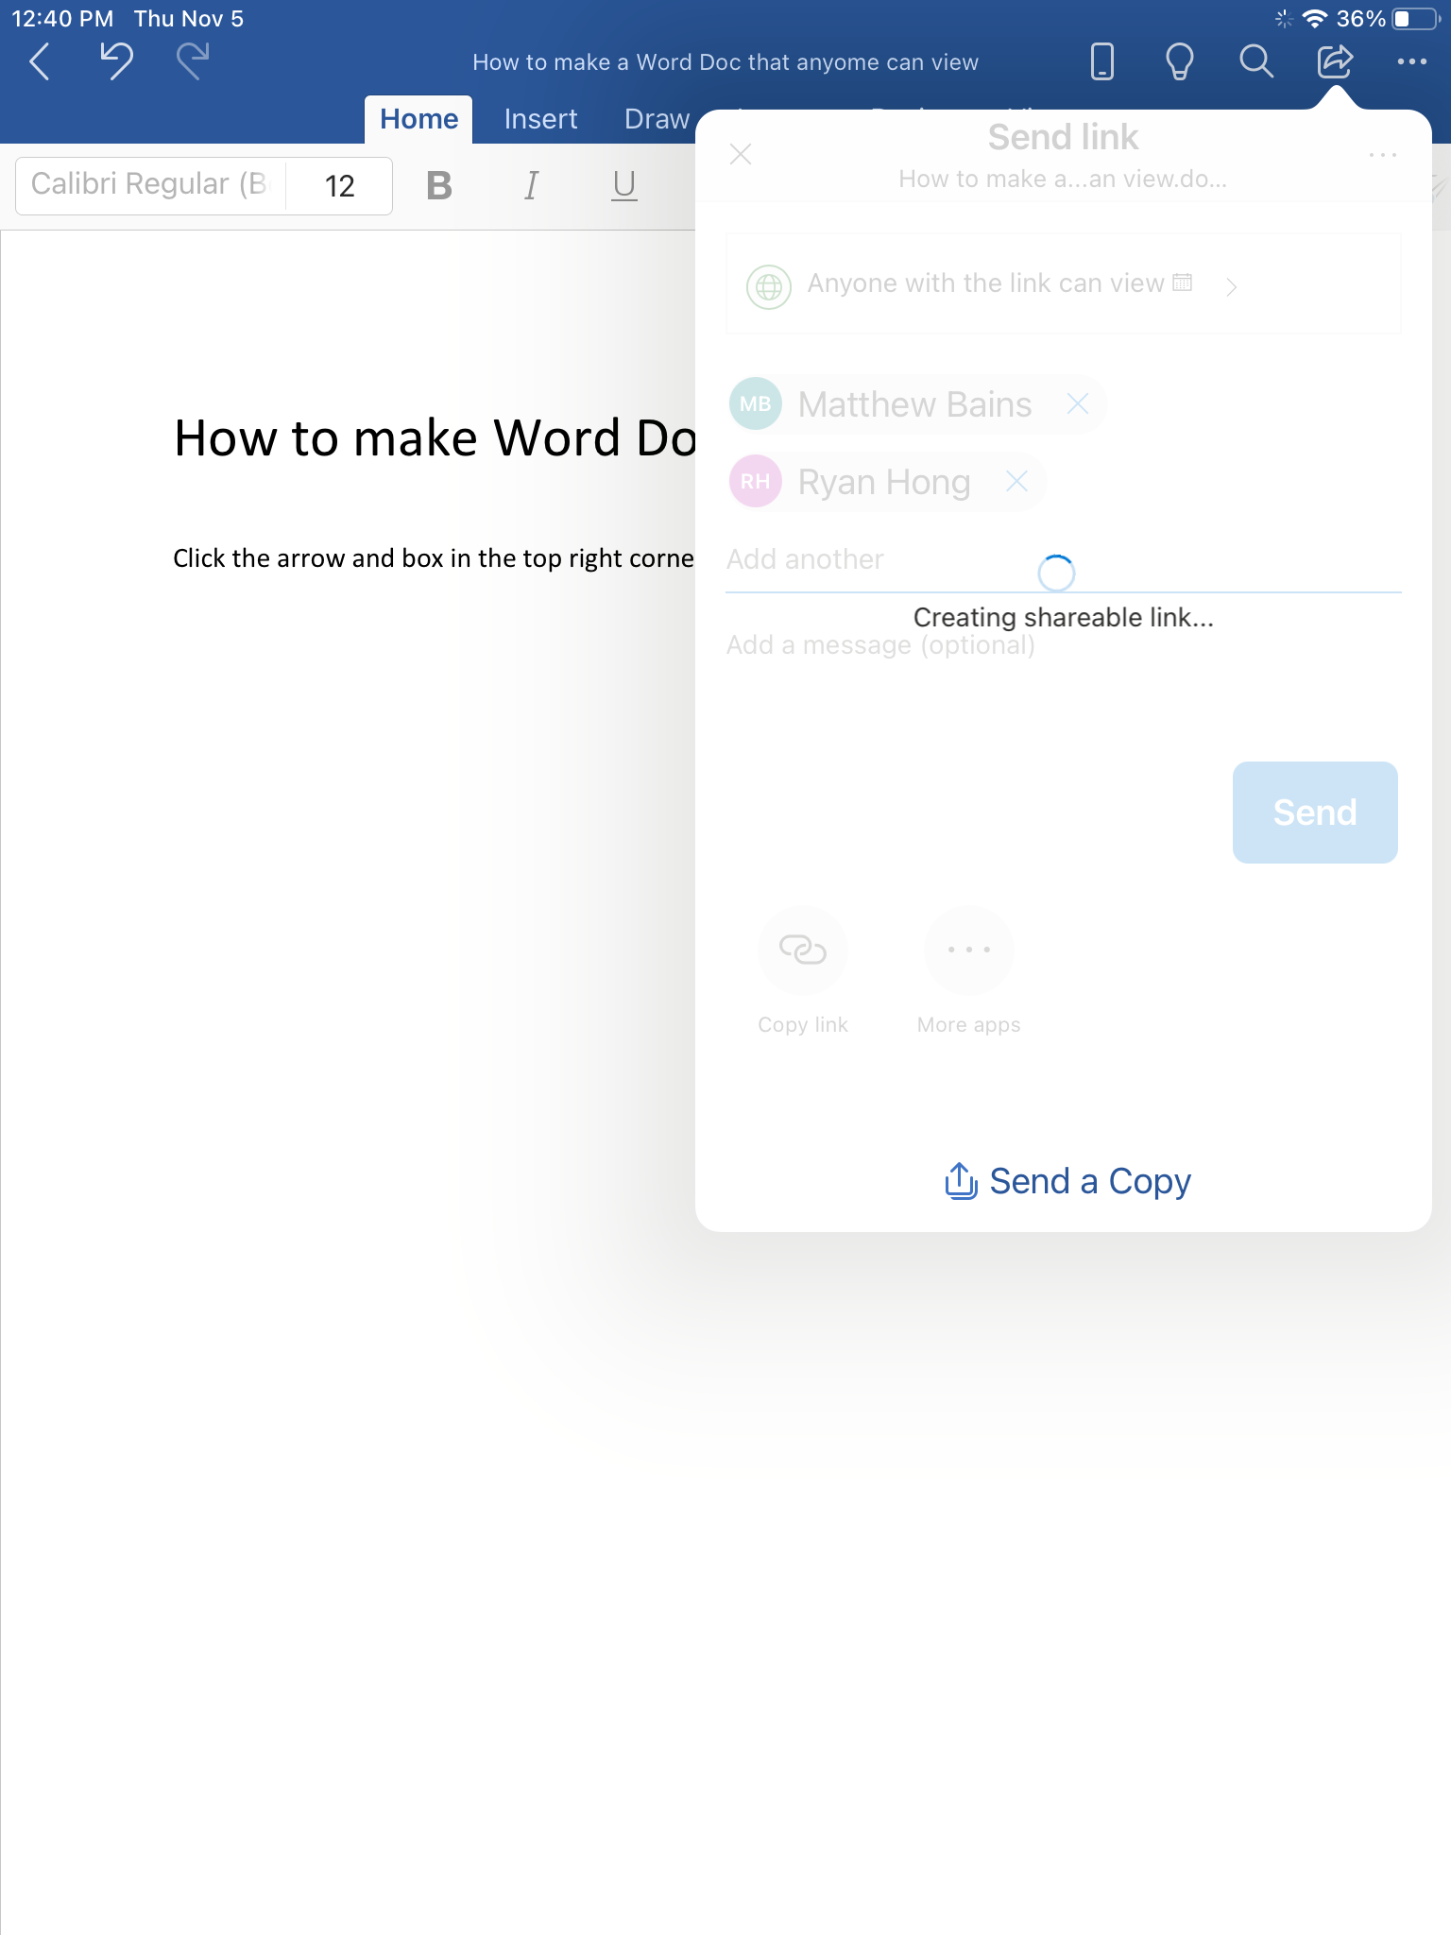
Finally, copy the link and share it on Fresh Grade under LA: Scary Short Story.

