NAME: _____________ MINI INQURY – GOING PUBLIC
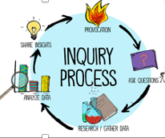
DATE: __________
LEARNING INTENTIONS:
- I can share my inquiry journey.

INITIAL QUESTION:

WHY I CHOSE THIS QUESTION:

NEW QUESTIONS THAT CAME UP AS I RESEARCHED:

USEFUL RESOURES | WHY THEY WERE USEFUL

ANALYZING (Important information; source) | BACKGROUND KNOWLEDGE (I already know) | SYNTHESIZING (Learning statements / New understandings)  - At the end of my inquiry,  - I am coming to understand……  - I am learning that…..

