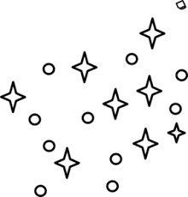
LIFE CYCLE OF STARS

Stars are born, grow old, and they eventually die.

This process is referred to as a star’s life cycle.

Stars begin their lives as part of a collection of dust and gas called a nebula.

Over time gravity pulls the gas and dust together.

As this collection of matter contracts, it gets very dense.

Eventually, nuclear fusion begins, and a star is born.

A PROTOSTAR is the earliest part of a star’s life.

Depending on their mass, stars can live a few billion years to as long as 200 billion years.

When a star nears the end of its life, it often expands to form a giant or even a super-giant.

Once a star runs out of fuel it can take a variety of forms, including a white dwarf, a neutron star, or a black hole.

White dwarves are old, small to medium size stars, which glow faintly.

Neutron stars are giant or super-giant stars, which have exploded in a massive sudden explosion called a SUPERNOVA.

The remaining matter then forms a dense NEUTRON STAR.

When the most massive stars die, they collapse into black holes. While the interior of black holes cannot be seen, the interaction of matter outside them can be detected. The gravitational forces within black holes are so strong nothing can escape, not even light.

