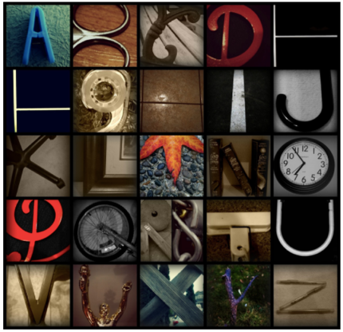
ASSIGNMENT: Alphabet Photography

LEARING INTENTIONS:
- I can apply the rule of thirds in my photographs.
- I can clearly show leading lines / perspective in my photographs.
- I can use a variety of angles to create a variety of different effects (worm’s eye view and
bird’s eye view)
- I can fill the frame.
- I can use software to create and enhance my photographs.

CRITERIA/RUBRIC
 | BEGINNING | DEVELOPING | APPLYING | EXTENDING
Composition | - Shows little use of:  - Rule of thirds  - Leading lines  - Worm’s eye view  - Bird’s eye view  - Filling the frame | - Shows some use of:  - Rule of thirds  - Leading lines  - Worm’s eye view  - Bird’s eye view  - Filling the frame | - Shows an ability to use:  - Rule of thirds  - Leading lines  - Worm’s eye view  - Bird’s eye view  - Filling the frame | - Clearly shows an ability to use:  - Rule of thirds  - Leading lines  - Worm’s eye view  - Bird’s eye view  - Filling the frame
Collage | - Does not use a grid of any sort and does not demonstrate an understanding of how to use the software | Uses a 5x5 collage but does not clearly demonstrates an understanding of how to use the software | Uses a 5x5 collage and clearly demonstrates an understanding of how to use the software | Shows creativity and clearly demonstrates an understanding of how to use the software
Digital enhancements | - Working towards understanding how to use a variety of editing skills using different graphic editing tools | - Demonstrates some knowledge of editing skills using different graphic editing tools | - Clearly demonstrates knowledge and application of a variety of editing skills using different graphic editing tools | - Clearly demonstrates use of a variety of editing skills using different graphic editing tools
ABC Photographs | - Some letters of the alphabet were missing or images were unclear.  - Many letters were physically created.  - Didn’t include at least 10 photos from nature.  - Most images were taken indoors. | - All 26 letters of the alphabet were taken. Some images were unclear as to which letter they represented.  - At least 5 letters were physically created.  - Didn’t include at least 10 photos from nature.  - Most images were taken indoors. | - All 26 letters of the alphabet were taken.  - 1-3 letters were physically created  - Most letters were found in the natural environment.  - A good variety of images from indoors/outdoors. | - All 26 letters of the alphabet were taken.  - Shapes of letters were not physically created and were found in the natural environment.  - A good variety of images from indoors/outdoors.

USEFUL RESOURCES:
- http://PIXLR.COM
- All links and examples posted on our class website.
- http://picmonkey.com
- Google images (type in the photography skill to view examples)
- Apple filters and photo editing tools

SELF ASSESSMENT
BEGINNING | DEVELOPING | APPLYING | EXTENDING

PEER ASSESSMENT
BEGINNING | DEVELOPING | APPLYING | EXTENDING

TEACHER ASSESSMENT
BEGINNING | DEVELOPING | APPLYING | EXTENDING

