LEARNING INTENTIONS:
- I can research relevant information and clearly explain why it is reliable.
- I can clearly present my information visually to my audience in a clear and simple manner.

INFOGRAPHIC - You have seen many examples of infographics in class and how they are used to display reliable research/information in an easy to understand way. According to Wikipedia, Information graphics or infographics are graphic visual representations of information, data or knowledge intended to present complex information quickly and clearly. Go to http://en.wikipedia.org/wiki/Infographic to read more about them. If you want to see more, simply do a ‘GOOGLE IMAGE’ search for ‘INFOGRAPHICS’.

General Rules About INFOGRAPHICS:
- Clearly show the data so it is easy to understand through images and numbers.
- Make the audience think about the information rather than about methodology, graphic design, the technology of graphic production or something else
- Do not distract the audience from your purpose and the information.
- Present many numbers in a small space.
- Make hard to understand data easy to understand.
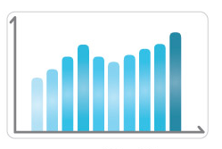
- Encourage your audience to compare different pieces of data
- Show your data/research at a broad overview and narrow your information.
- You should have a clear purpose as to why you created your infographic.
- Images should be related to the data presented.

STUDENT GENERATED CRITERIA:
WHAT TO INCLUDE: | ✓/ X | Things to Improve | ✓/ X
1.) Title
- Includes a description of what the purpose of your infographic
2.) Reliable Research (statistics)
- Must include a minimum of 2 reliable sources for each piece of data
- Must include 3 reasons why your 2 sources from above are reliable
3.) Visual Presentation  - 3-5 researched statistics  - Different images for each piece of information displayed in a creative way |  |  | 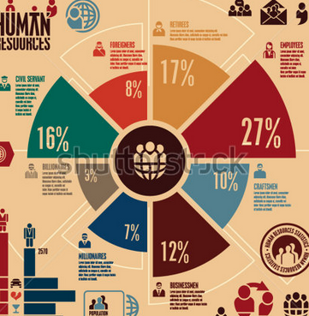
4.) Images to represent statistics/data/information
- The images are related to the information being displayed.
5.) Poster
- Coloured
- Neat and presentable
- Bordered
- Creative

